Dear Clients
We have compiled this information to assist with selecting the right rams for your enterprise. The information has been taken from sources such as Sheep Genetics (Lambplan). In the past we had this information in the catalogue but this way we can put it all on one sheet which should make it easier to read. All this info is to assist you with making the right ram selection but we are also there to help on sale day if you would like assistance.

BUYING THE RIGHT RAMS
Sire selection is NOT ‘one size fits all’. Producers who are able to more reliably select the right terminal sire to suit their ewe type production system and market specifications, can more readily turn off lambs at the appropriate weight and fat score in a shorter time period.

About 70% of what a sheep looks like goes down its throat!
That makes it visually a bit hard to work out which sheep are truly superior and will breed you the best lambs - ASBVs are a great tool to help work out which ram has the best genes to pass on to their progeny.
This year in our catalogue we have included additional information to help show why a particular ram may appear more forward than another on sale day. Twin/single. Date of birth/Age
TRAITS THAT DEFINE THE VALUE OF TERMINAL SIRES - ASBVs
The skills in selecting terminal sires for lamb production is to identify those sires that have desirable genes that produce lambs with high growth rate, low fat (lean) and better carcase conformation. At present, we cannot directly measure the genes of an animal. LAMBPLAN can however provide an estimate of the value of a sire’s genes by looking at his own performance for certain traits and that of his relatives. This estimate is called an Australian Sheep Breeding Value (ASBV). For terminal sires there are four main traits to concentrate on these being:
- Weaning weight (Wwt) & Post weaning weight (Pwt) – describe the animal’s genetic merit growth rate. A positive ASBV means the animals progeny will be genetically faster growing. ie they reach market weight at an earlier age.
- Post weaning fat (Pfat) – describe the value of each animal’s genes for fat depth at constant weight – a negative ASBV means that an animal’s progeny will be a genetically leaner animal.
- Post weaning eye muscle depth (Pemd) – describe the value of each animal’s genes for eye muscle depth at constant weight – a positive ASBV means a genetically thicker-muscled animal, and one that will have slightly more of its lean tissue in higher-priced cuts.
Why should lamb producers use LAMPLAN? LAMPLAN ASBVs enable comparison across flock within a breed and across terminal sire breeds. For buyers not familiar with the individual ASBVs we also provide a Carcase Plus Index (Carc+) which is calculated on the ASBV traits, plus newer indexes: Trade$ and Export$ Indexes.

LAMBPLANs Carcase Plus Index (Carc+) For producers selling lambs at around 5-6 months, it is especially relevant, giving the best dollar return under today’s market requirements. High Carcase Plus Index also allows growers to produce lambs that can be carried to higher weights without getting too fat. Carc+ Index is made up of: 65% growth, 30% muscle, 5% fat.

Trade$ and Export $: These indexes are essentially fat optimisation indexes. They aim to highlight animals that are more appropriately suited to either the trade weight (roughly 19kg carcase) or export weight (roughly 26kg carcase) ends of the market.

Parameters | Trade $ | Export $
Carcase wt. target | 19kg | 26kg
PWT target | >+10 | >+10
PFAT target | Optimised at 0 | Optimised at -1.5
PEMD target | >1 | >1

While production of lambs for any market requires appropriate leanness, it is recognised that for the earlier finishing trade weight lambs, excessive leanness is undesirable due to potential difficulty in finishing. Conversely, export weight lambs need to ensure there is not excess fat. These indexes are designed to meet different breeding objectives. They are simply a guide to assist animal selection, however when doing so commercial producers should first consider their own breeding objective. This will involve considering your current ewe base, the environment they are run in and the target market for their progeny.
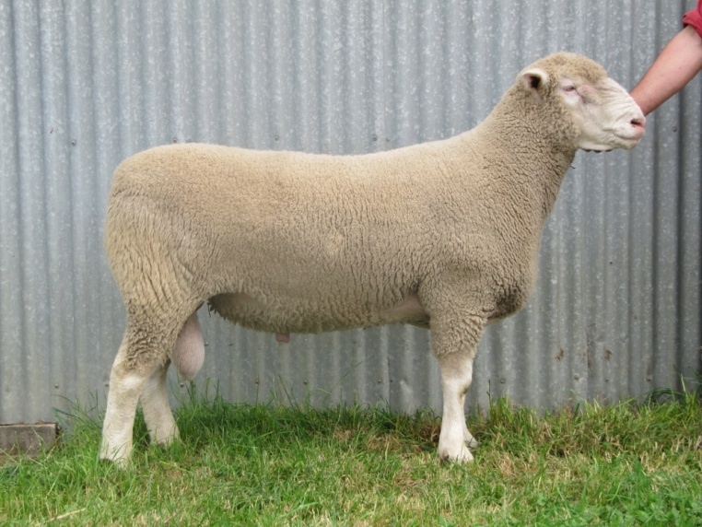
We have been using LAMBPLAN since its inception. We find it an important aid for helping to select the right ram. Data for Lambplan is collected and recorded by us in the following ways:
All our lambs are recorded including sire and dam pedigree, twin/single, male/female, date of birth.
• Birth weight is taken on all progeny born, their Lambing ease is noted (that is whether it was an unassisted birth) and their gestation length recorded (this is done by recording the joining date and birth date – we have done a lot of extra work in this area by hand mating in addition to AI as they are the only ways Lambplan recognises this information. A sire that influences a ewe to lamb a day or two earlier has a much reduced chance of lambing difficulties.
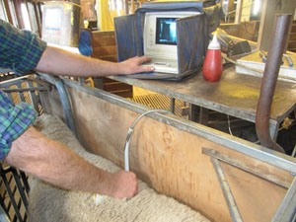
- Weaning 3-4 months weighing of all lambs born that year.
- Early Post Weaning 5-6months - Scanning for eye muscle depth and fat. Weight is also recorded again at this stage.

To help place where the individual rams are classed in Australia we also provide in the catalogue a percentile report.
Eg - if your absolute priority is for low birth weight (lambing ease) look for the rams in the catalogue that have average or lower ASBVs for birth wt. If your priority is for growth look at the Wwt and Pwt above average etc .

Band | Bwt | Wwt | Pwt | Pfat | Pemd | Carcase | Trade $ | Export$
% | kg | kg | kg | mm | mm | Plus | Index | Index
Av. | 0.31 | 7.6 | 11.8 | -0.6 | 1.2 | 175.1 | 108.2 | 106.7

Both Valma and Spring Valley Studs are well above the average for these growth traits when compared with all terminal animals in Australia born in 2015 (See attachment for graphs on where we sit), so you can be sure you are getting amongst the best rams in Australia on Lambplan data (genetic merit). In addition to the breeding potential of these rams we also place the greatest emphasis on structure of all the rams.
The rams catalogue are considered by us the best we have produced for the year from over 1000 stud breeding ewes for both Lambplan figure and structure.
---------------------------------------------------
Genetic Research Benefits Our Clients
Both Valma and Spring Valley have been participating in genomic testing since its inception. This gives extra information on these rams that will be passed onto its progeny.
- The DNA testing allows more accurate selection (particularly on hard to measure traits such as eating quality – tenderness & flavor or those that occur later in life).
- A shorter generation interval (because animals can be selected accurately and used at a young age). We always use ram lambs in our breeding programs.
For our ram buyers, the process of identifying the rams to best suit their ewes remains unchanged. The genomic information provided by the SNIP chip test will be sitting behind the ASBVs for an individual animal. It is essentially an enhancement of normal ASBVs.
By combining the ASBVs obtained from our raw data collection (birth wt, wean wt, early post weaning wt, scans and fat score), and the genomics data gained by participating the SNIP research , it is giving us and all our clients the greatest volume of information with the best available accuracies on a large variety of traits.

